Software Requirement Specification

Version No.1

Date: 1-02-11

Project Name: WebStore Application

Project Code:

Copyright Notice

The contents of this document are proprietary to <HCL Technologies LTD>. and shall not be disclosed, disseminated, copied, or used except for purposes expressly authorized in writing by <HCL Technologies LTD >.

Revision History

| Version No | Date | Prepared by / Modified by | Significant Changes |
| --- | --- | --- | --- |
| 1 | 1-02-11 | Deepika, Sudha Giriprasad, | Identified requirements of the application |
| 2. | 7-02-11 | Deepika | Modified the requirements and Screen prototypes, tables and ER diagram are added |
| 3. | 16-02-11 | Deepika | Added class diagrams, sequential  flow diagrams and use case  diagrams |
| 4. | 17-02-11 | Deepika,Giri | Modified operational conceptsAnd scenarios, constrains andReferences |
| 5. | 24-02-11 | Deepika | Removed design requirementsfrom SRS. |

Glossary

|  |  |
| --- | --- |
| Abbreviation | Description |
|  |  |
|  |  |

**Table Of Contents**

1 Introduction 5

1.1 Purpose 5

1.2 Scope 5

2 Overview of the Document 5

3 System Context 6

3.1 Product Perspective 6

3.1.1 System Overview & Context Diagram 6

3.1.2 Operational Concepts and Scenarios 7

3.1.3 System Interface 9

3.1.4 Memory Constraints 10

3.1.5 Site Adaptation Requirements 10

3.2 Product Functions 10

3.3 Constraints 10

3.4 Assumptions and Dependencies 11

3.5 Apportioning of Requirements 11

4 Specific Requirements 11

4.1 Organizational Requirements 11

4.2 Business requirements 11

4.3 User Requirements 11

4.4 External Interface Requirements 12

4.5 Functional Requirements / System Features 17

4.6 Performance Requirements 29

4.7 Acceptance Criteria 29

4.8 Logical Database Requirements 30

4.9 Design Constraints 33

4.10 Testing Requirements 34

4.11 Compliance to Standards 38

4.12 Software System Attributes 38

5 Derived Requirements 38

6 Validation 38

6.1 Validation strategy 38

6.2 Validation criteria 39

6.3 Validation Constraints 39

7 References 39

# 1 Introduction

## Purpose

This document describes the online shopping portal functionality. With this portal user can navigate through a web-site where a user can do shopping online.

## Scope

Many websites on internet are providing online shopping facilities. The web store online shopping website is generic enough to directly support all types of products/categories. Also features a fully functional cart which simultaneously stores products as well as items.

It Represents the commodities for sale under the below mentioned classifications:

a. Catalog

b. Category

c. Sub-Category

d. Product/Item

In addition it also offers shopping categories like IPods at reasonable prices and mobile phones of all major brands like Nokia, Samsung, Sony Ericsson and LG are offered online.

# Overview of the Document

This document describes the online shopping portal functionality. With this portal user can navigate through a user can do shopping online. This web-site allows a new user to register with the web-site and provides cart for shopping. A registered user can do shopping by logging-in to his/her account.

# System Context

## Product Perspective

Car Audio & Video, TV & Video, Home Theater & Audio, MP3 & Portable, Cameras & Camcorders are the products available in the online Web Store portal where the customers can select the products for buying. The products which are available in the shopping portal are independent and totally self contained.

### System Overview & Context Diagram

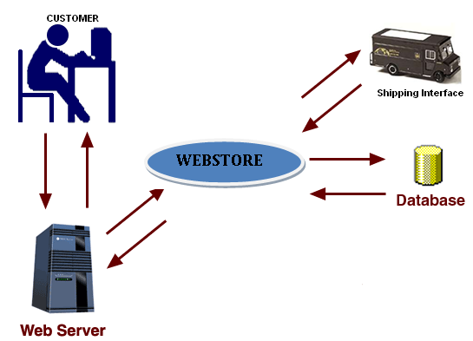

### Operational Concepts and Scenarios

|  |  |
| --- | --- |
| **REQ-NO** | **Description** |
| REQ-101 | User clicks on **Sign-In** link |
| REQ-102 | User enters **username** |
| REQ-103 | User enters **password** |
| REQ-104 | User clicks on **Login** button after entering correct username and password |
| REQ-105 | User navigates to respective page by clicking on any one of the links provided on top of the Login page. |
| REQ-201 | User clicks on **Create an account now** link in Login page and User enters **Registration** page |
| REQ-202 | User enters the **username** whichever username he wants |
| REQ-203 | User enters the **password** whichever password he wants |
| REQ-204 | User confirms his password by entering the same password which he/she enters in password field |
| REQ-205 | User enters his **first name** |
| REQ-206 | User enters his **last name** |
| REQ-207 | User enters his **Date Of Birth** |
| REQ-208 | User enters his **Email-ID** |
| REQ-209 | User enters his **address** |
| REQ-210 | User enters his **phone number** |
| REQ-211 | User enters his **city** name |
| REQ-212 | User enters his **state** name |
| REQ-213 | User enters the **pin code** |
| REQ-214 | User enters his **country** name |
| REQ-215 | User clicks on **Register** button after entering valid data |
| REQ-216 | User navigates to respective page by clicking on any one of the links provided on top of the registration page. |
| REQ-301 | User clicks on **My Account** link after logging in to see the profile. |
| REQ-302 | User updates his/her information/details/profile |
| REQ-303 | User can Sign-out from his/her account and can navigate to Home page, Cart page etc. |
| REQ-401 | User clicks on Home link. A page will be displayed showing all the available Catalogs. |
| REQ-402 | User selects any Catalog by clicking on a particular catalog image/name and all the available Categories under the selected catalog will be displayed. |
| REQ-403 | User selects a category from the resulting categories list by clicking on that particular category image/name and all the products/items under the selected category will be displayed. |
| REQ-404 | User selects a product/item from the resulting products/items list just by clicking on the image/name of that particular product/item |
| REQ-405 | User navigates to respective page by clicking on any one of the links provided on top of the Home page. |
| REQ-501 | User clicks on **Add to Cart** icon of the selected product to add it to cart. |
| REQ-502 | User can get his/her Cart after logging in also, if he adds items to Cart before logging in. But the user cannot get his/her Cart if he logs in after he/she logs out. |
| REQ-503 | User navigates to respective page by clicking on any one of the links provided on top of the Cart page and user can navigate to Home page by clicking on Keep Shopping icon in cart page. |
| REQ-601 | User can update the cart by clicking on **Update** button, if he/she made any changes to cart like changing the quantity of a product etc. |
| REQ-701 | User removes the selected product from cart by clicking on **remove** |
| REQ-801 | User clicks on **Checkout** icon to order/purchase the products and Billing page is displayed and Billing page has nine fields and one button. |
| REQ-802 | User enters the **shipping address** |
| REQ-803 | User enters the **phone number** |
| REQ-804 | User enters the **city** name |
| REQ-805 | User enters the **state** name |
| REQ-806 | User enters the **pin code** |
| REQ-807 | User enters the **country** name |
| REQ-808 | User enters the **type** of the **credit card** |
| REQ-809 | User enters the **credit** **card number** |
| REQ-810 | User enters the **expiry date** of **credit card** |
| REQ-811 | User clicks on **Continue** button and user will be directed to **Order** page which shows the order details such as ordered date, order id etc. |
| REQ-812 | User navigates to respective page by clicking on the any one of the links provided on top of the Billing page. |
| REQ-813 | One more order then he/she can do so by clicking on **Home** icon |
| REQ-901 | User clicks on **Help** and a page will be displayed guiding the user. |
| REQ-1001 | User clicks on **Sign-Out** link to sign-out from his/her account. |
| REQ-1101 | Webstore provides **24/7** technical support. |
| REQ-1102 | **Product images** are good representations of what Webstore is offering. |
| REQ-1103 | **Home page** provides an overview of key products that Webstore is offering to buy. |
| REQ-1104 | Provides **safety** by hiding user's details at the time of Registration and Login and Paying price for the product. |
| REQ-1105 | System should not **crash** when multiple users are accessing Webstore at a time. |
| REQ-1106 | The **response time** of the system is approximately 1-2 seconds. |

### System Interface

User Interface

Web store provides a user friendly user interface. It provides the user to register with the website and login to the account if the user is already registered. It guides the user if a new user visits the website. It provides a way to buy the products as well as to pay online.

Hardware Interface

There are no hardware interfaces.

Software Interfaces

The web store application runs on Tomcat server which is an application server. It is used to connect the user to the web store. It acts as a medium between the website and the user.

Communication Interfaces

Shipping interface

The shipping interface is used to ship the ordered items to the customer. It is used to deliver the items to customer’s shipping address.

Database Interface

The JNDI is used as database interface. It is used to connect the webstore application to the database.

Credit card Interface

The credit card interface is used for online payment. It is used for the

payment of the products or items which has been purchased online.

### Memory Constraints

The above system has no memory constraints.

### Site Adaptation Requirements

New data tables created for this system must be installed on the organization’s existing MySql Server.

## Product Functions

The web store application maintains the registered user details and also updates the user profile if there are any changes made by the user.

## Constraints

User can order maximum of 999 items\products of particular type at a time.

Web store runs on intranet only.

More than 100 users cannot access the website at same time.

## Assumptions and Dependencies

It is assumed that Webstore will depend on PayPal to interface with the Payment Systems, for the users or customers to pay for the products which they have purchased.

## Apportioning of Requirements

As such for now there are no apportioning requirements for this project.

# Specific Requirements

## Organizational Requirements

* The Home Page will be the first port of call for most visitors to the site. It should provide a good overview of all the main key products on sale of the site as well as clearly highlighting information and products to encourage site visitors to review the product ranges and special offers.
* Making the main product categories available throughout the site as part of the navigation system to give customers constant access to all the products available and allow the user move easily through the product options.

## 4.2 Business requirements

* Choosing a web host that offers 24/7 technical support – **REQ 1101**
* Ensuring that the product images are good representations of what WebStore is selling - **REQ 1102**
* Home page provides an overview of key products that WebStore is offering to buy – **REQ 1103**
* MySql data server is required

## 4.3 User Requirements

* In order to access the Web store the user must be able to have access to a computer, which has an internet connection
* User must also have a bank account and a credit card

## External Interface Requirements

#### Screen Prototypes

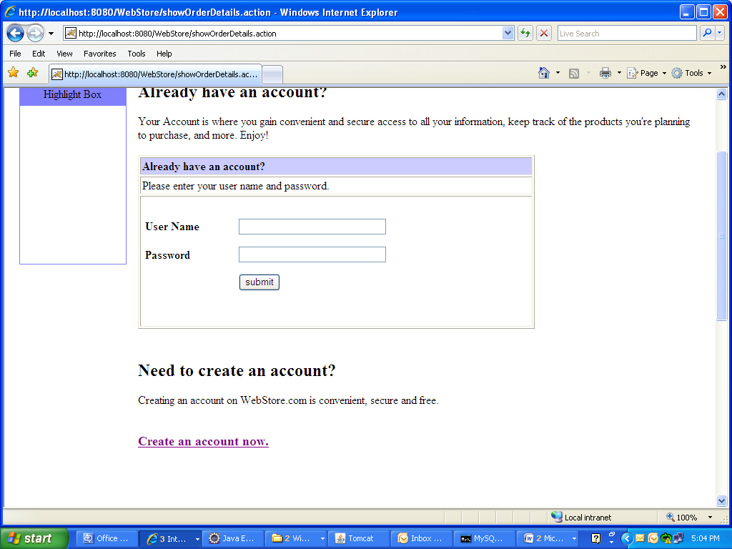

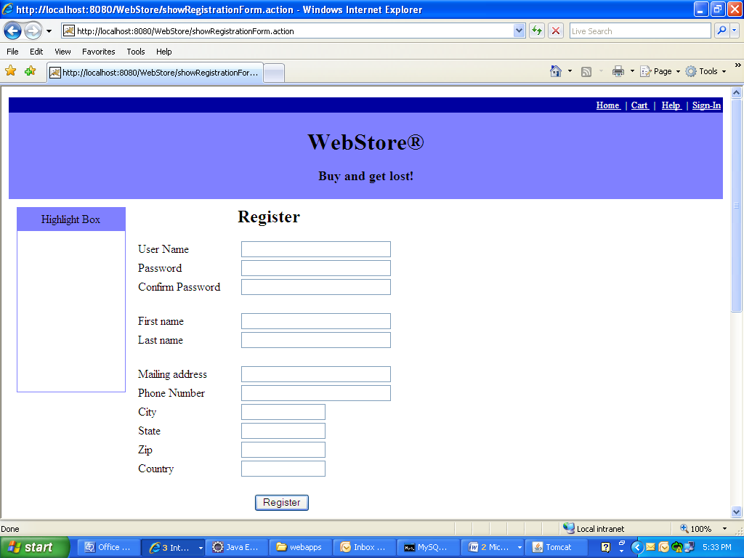

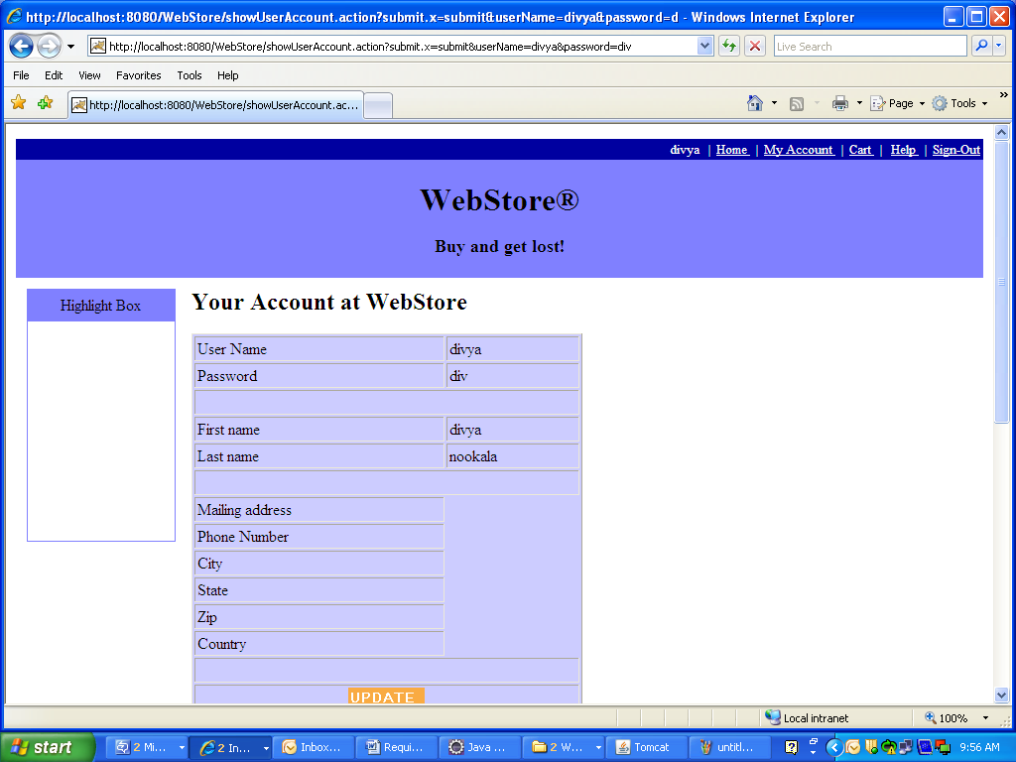

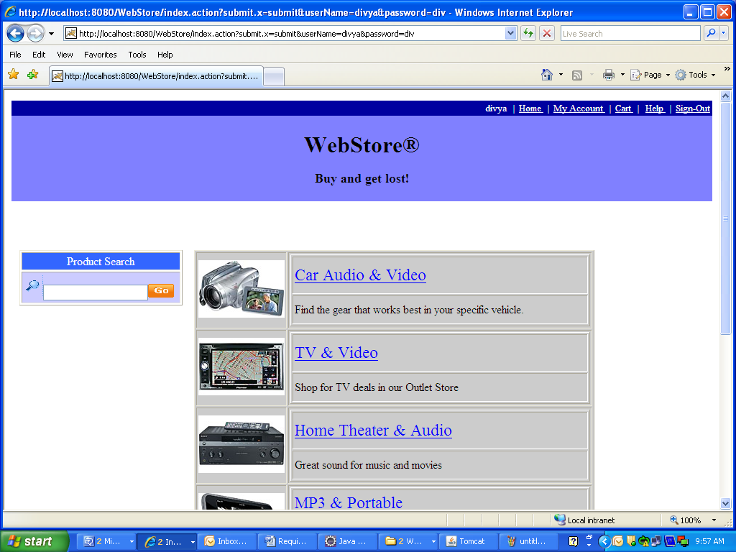

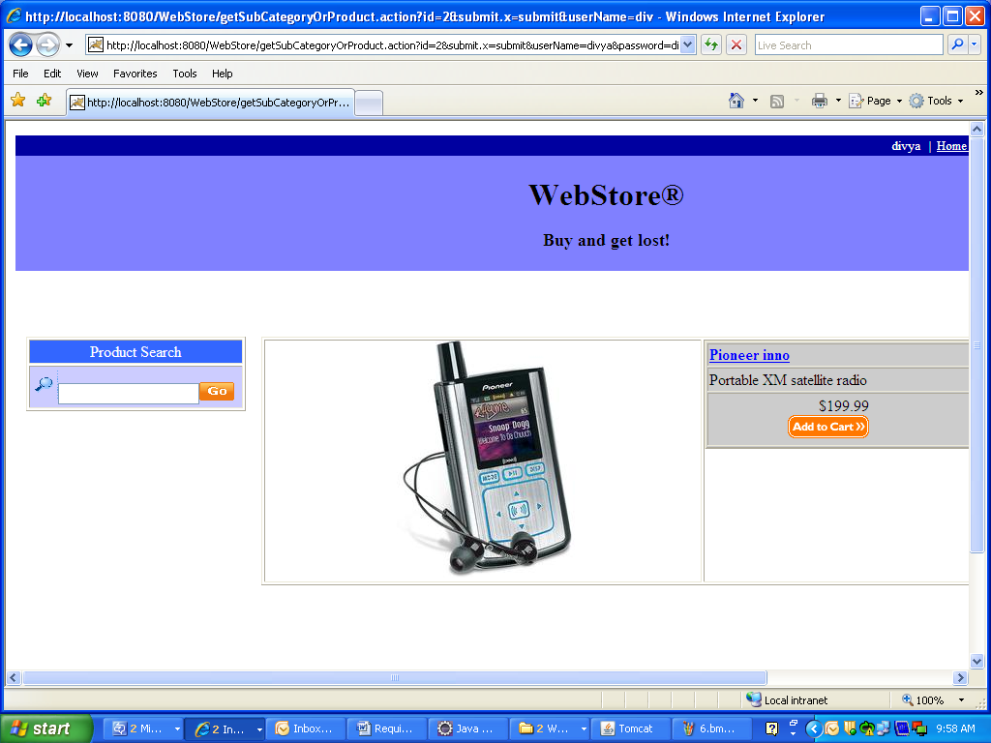

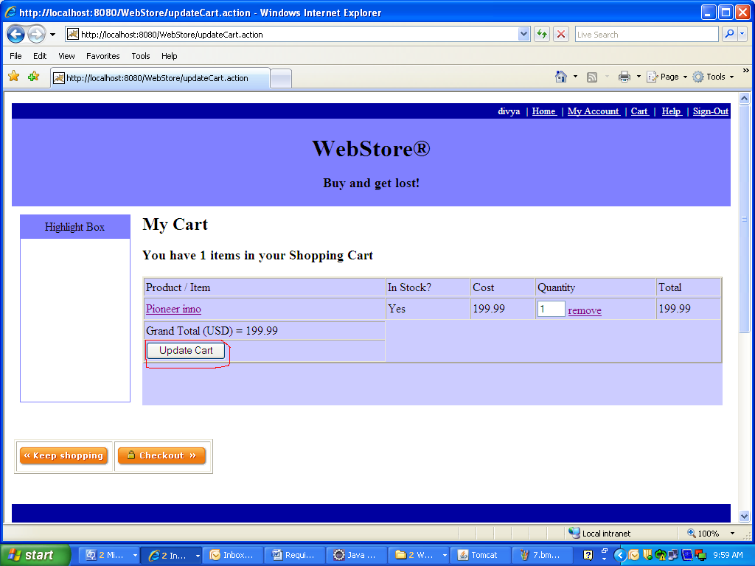

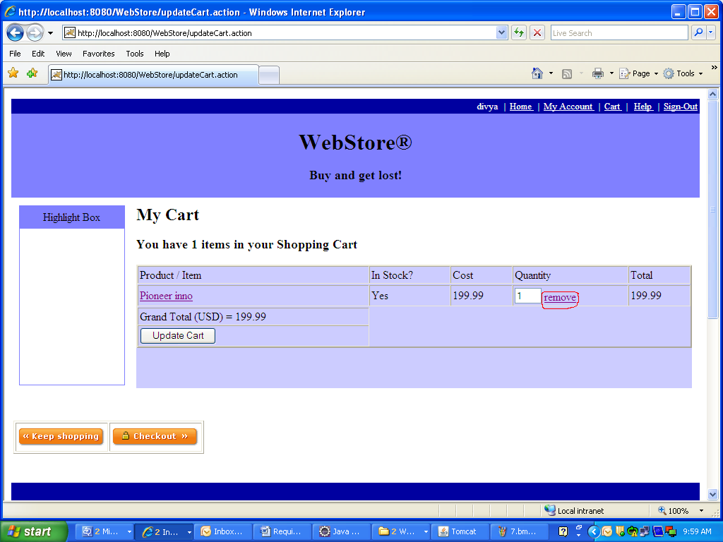

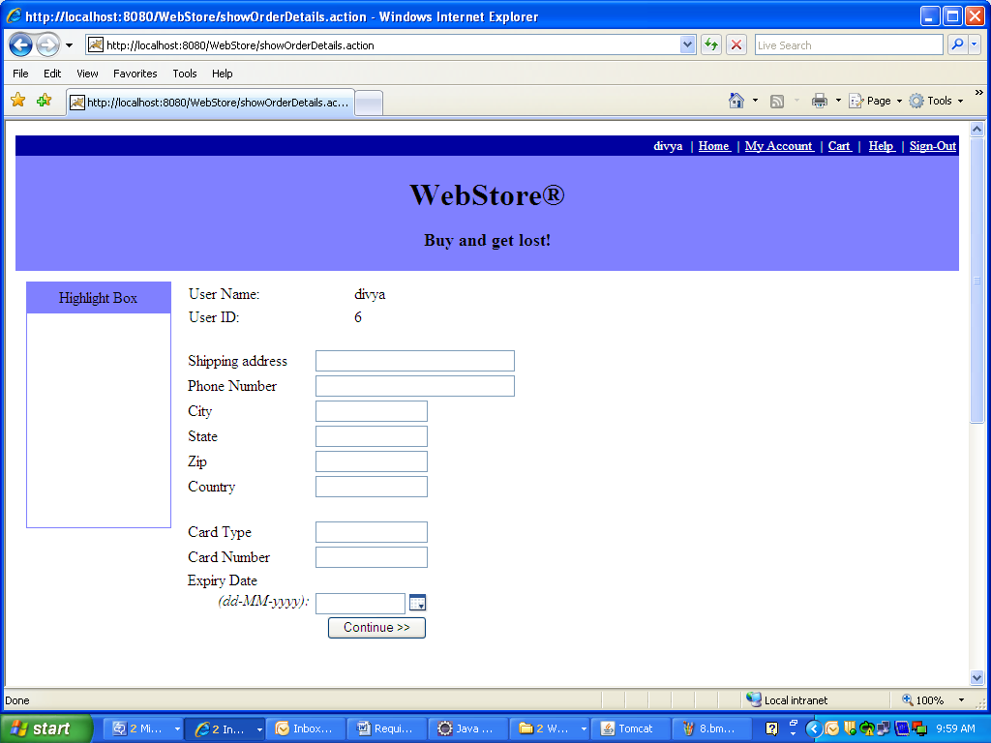

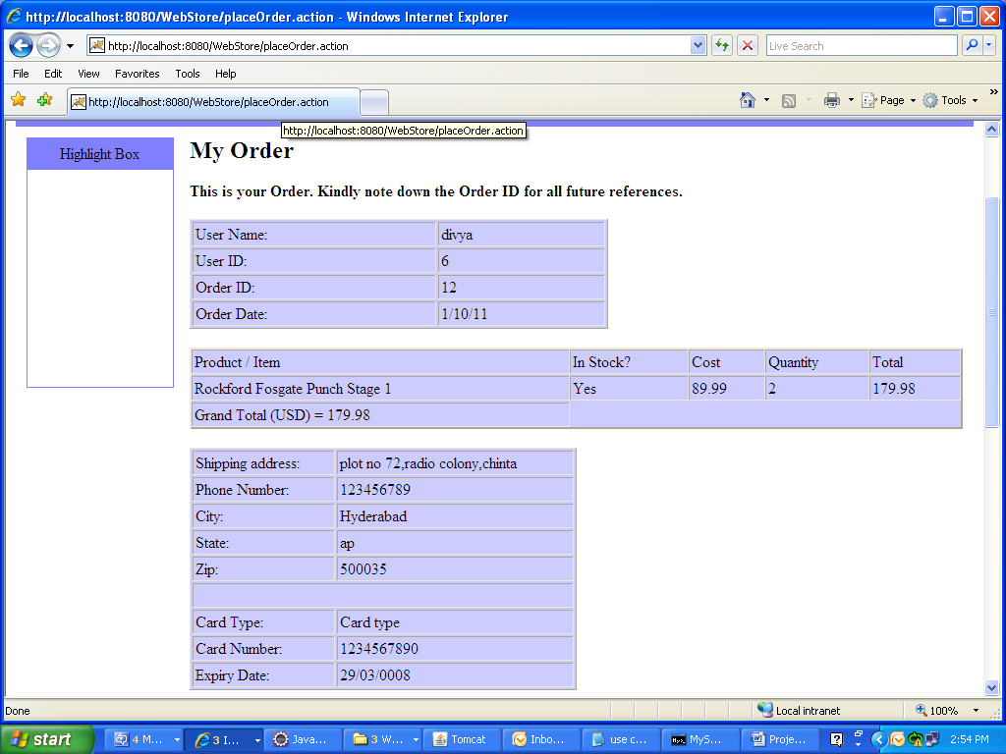

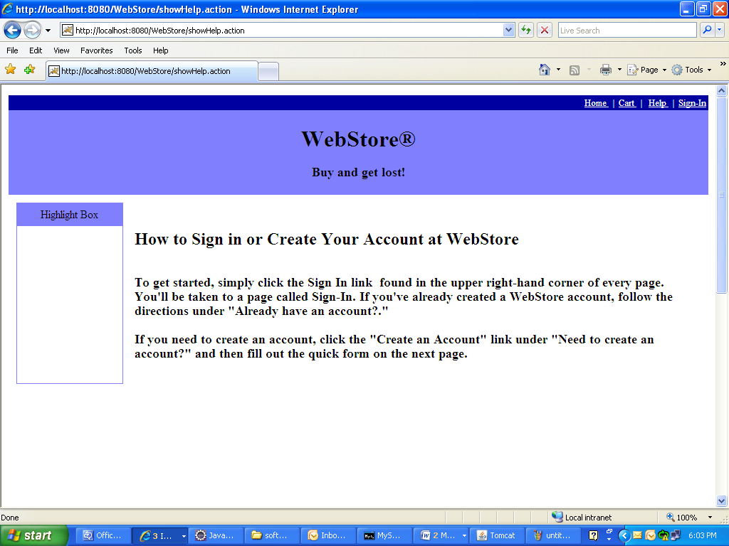

## Functional Requirements / System Features

### Requirement / Module / Use-case for Log-in

* + - 1. **Description**

This use-case describes the **Login** page functionality.

REQ-101: The **Login** page has two fields (One is **UserName** and the other is **Password**) and one (**Login**) button.

REQ-102: The **UserName** field is marked mandatory and the registered user must enter his/her Username in this field to login.

REQ-103: The **Password** field is marked mandatory and the registered user must enter his/her Password in this field to login.

REQ-104: Once the registered user enters valid **UserName** and **Password** and clicks on **Login** button, the user will be logged in to his/her account and the user will be directed to **Home** page displaying the Username of the user on the top of the page.

REQ-105: The login screen provides few links to go to **Home** page, **Cart** page, **Login** page and **Help** page on top of the page.

#### 4.5.1.2 Screen Flow / Business Flow & User Actions

User enters the **Username** and **password**

User will be logged-in to his/her account and **cart** page will be displayed.

User clicks on **Login** button

If validated

#### 4.5.1.3 Business Rules & Validations

The business rule to be considered while entering this screen is, the user must be connected to the website and the user must click on **Sign-In** link.

The business rule to be considered while moving to the next page is that the **username** and **password** should be entered and both the fields should be valid.

### Requirement / Module / Use-case for Registration

#### 4.5.2.1 Description

This use-case describes the **Registration** page functionality.

REQ-201: New user can register by clicking on Create an account now. A registration page will be displayed with 13 fields and one button.

REQ-202: The **UserName** field is marked mandatory and this field will accept letters, digits and any other special symbols. This field accepts maximum of 20 characters only.

REQ-203: The **Password** field is marked mandatory and this should be at-least 6-8 characters long. It accepts alphabets, numeric’s and special symbols.

REQ-204: The **Confirm Password** field will be marked mandatory and this should match with the **Password**.

REQ-205: The **FirstName** will accept only alphabets. This field accepts maximum of 20 characters only.

REQ-206: The **LastName** field will accept only alphabets. This field accepts maximum of 20 characters only.

REQ-207: The **Date of Birth** field is mandatory and this field accepts digits only.

REQ-208: The **Email-ID** field is mandatory and this field will accept alphabets, digits and two special characters (@ and dot) only.

REQ-209: The **Address** field is marked mandatory and this field accepts alphabets, digits, special symbols.

REQ-210: The **Phone Number** field is marked mandatory and this field will accept only digits excluding alphabets and any other special characters.

REQ-211: The **City** field is marked mandatory and this field will accept only alphabets.

REQ-212: The **State** field is marked mandatory and this field will accept only alphabets.

REQ-213: The **Zip** field is mandatory and this field will accept only numbers.

REQ-214: The **Country** field is mandatory and this field will accept only alphabets.

REQ-215: Once the user enters valid data in all the fields and clicks on **Register** button, the user will get registered with WebStore and user will be directed to **Home** page.

REQ-216: The **Registration** page also provides an option to **Login** for registered users using the link **Sign-In** provided at the top of screen and few links to go to **Home** page, **Cart** page and **Help** page etc.

#### 4.5.2.2 Screen Flow / Business Flow & User Actions

User enters all the details required in the registration page.

User will be registered and can be able to purchase/order the products.

User clicks on **Register** Button.

Checks for validations

#### 4.5.2.3 Business Rules & Validations

The business rule to be considered while entering this page is the user must be connected to **Webstore** and the user must click on Sign-In link.

The business rule to be considered while moving to next page is that all the mandatory field values must be filled by the user and the data in all the fields should be valid.

### Requirement / Module / Use-case for My Account

#### 4.5.3.1 Description

This use-case is describes how to navigate to Logged-in User’s profile page.

REQ-301: Once the user Logs-in to the web store, he/she can view his/her profile by clicking on **My Account** link. When User clicks on **My Account** link, the User Information page will be displayed showing all the details of the user which he enters at the time of registration.

REQ-302: The User Information page provides one **Update** icon at the bottom of the page to change/update his/her profile/details.

REQ-303: This page provides few links to **Sign-out** from his/her account and to go to **Home** page, **Cart** page and **Help** page provided at the top of screen. This page also provides the flexibility for the user to change his/her **Password** through the link **Change Password**.

#### 4.5.3.2 Screen Flow / Business Flow & User Actions

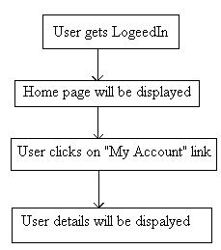

#### 4.5.3.3 Business Rules & Validations

The business rule to be considered while entering this page is the user must Login. The business rule to be considered while moving to the next page is, to make sure that the user clicked on **My Account** link.

### Requirement / Module / Use-case for Home

#### 4.5.4.1 Description

This use case describes about all the available products in the portal.

REQ 401: User clicks on **Home** link and a page will be displayed showing

All the available **Catalogs** in the portal along with the images.

REQ-402: User selects any **Catalog** by clicking on a particular catalog

Image/name and all the available **Categories** under the selected catalog will be

Displayed along with images.

REQ-403: User selects a category from the resulting categories list by

Clicking on that particular category image/name and all the **products/items**

Under the selected category will be displayed along with the images, if there are

any products/items available in that category.

REQ-404: User selects a **product/item** from the resulting products/items

List just by clicking on the image/name of that particular product/item. The product/item will be displayed along with the image, description and price

REQ-405: Home page provides few links to navigate to **Home** page, **Cart** page, **Login** page etc.

#### 4.5.4.2 Screen Flow / Business Flow & User Actions

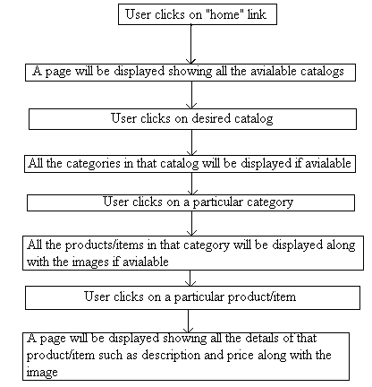

#### 4.5.4.3 Business Rules & Validations

The business rule to be considered while entering this screen is the user must click on **Home** link.

The business rule to be considered while navigating to the next page is the user must select at least one of the available catalogs.

### Requirement / Module / Use-case for Adding to the cart

#### 4.5.5.1 Description

This use case describes adding a product/item to the cart.

**REQ-501:** Once the user selects a product/item by clicking on that particular product/item, he/she can add them to the cart by clicking on **Add to cart** icon (which will be present beside that product/item) and after the product is added to cart, the cart page will be displayed showing the details of products/items that are added to cart.

**REQ-502:** User can get his/her Cart after logging in also, if he adds items to Cart before logging in. But the user cannot get his/her Cart if he logs in after he/she logs out.

**REQ-503:** User navigates to any page by clicking on any one of the links provided on top of the Cart page and user can navigate to Home page by clicking on **Keep Shopping** icon in cart page.

#### 4.5.5.2 Screen Flow / Business Flow & User Actions

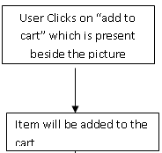

#### 4.5.5.3 Business Rules & Validations

The business rule to be considered while entering this screen is, the user (registered/unregistered) must select a category.

The business rule to be considered while navigating to next page is, the user (registered/unregistered) must add a product to cart.

### Requirement / Module / Use-case for updating the cart

#### 4.5.6.1 Description

This use case describes updating the existing cart.

REQ-601: Once the user adds the products to cart, he/she can update the cart (if there are any changes made to cart) by clicking on **Update** link. If the user changed the quantity of that particular product/item by changing the value in the Quantity field and if the user clicks on update then the cart will be updated with the new quantity which has been set.

#### 4.5.6.2 Screen Flow / Business Flow & User Actions

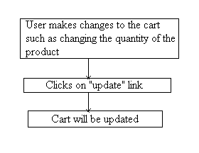

#### 4.5.6.3 Business Rules & Validations

The business rule to be considered while entering this screen is that the user must add at least one item to the cart.

The business rule to be considered when navigating to next page is the user must update the cart.

### Requirement / Module / Use-case for removing from the cart

#### 4.5.7.1 Description

This use case describes removing the existing products/items from the cart.

REQ-701: Once the user adds the products to cart, he/she can remove those products/items from the cart by clicking on **Remove** link.

#### 4.5.7.2 Screen Flow / Business Flow & User Actions

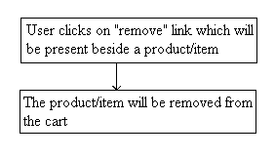

#### 4.5.7.3 Business Rules & Validations

The business rule to be considered while entering this screen is that the user must add at least one item to cart.

The business rule to be considered when navigating to next page is the user must remove at least one product/item from the cart.

### Requirement / Module / Use-case for order

#### 4.5.8.1 Description

This use case describes how to **order/purchase** the products after adding them to cart.

REQ-801: User clicks on **Checkout** icon to order/purchase the products and billing page is displayed with 13 fields and one button.

REQ-802: The first one is the **Shipping Address** field and it is marked mandatory. It accepts alphabets, digits and special symbols.

REQ-803: The next field is the **Phone Number** and it is mandatory. It accepts only digits.

REQ-804: The next is the name of the **City** and it is mandatory. It accepts only alphabets.

REQ-805: The next field is the **State** name and it is mandatory. It accepts only alphabets.

REQ-806: The next is the pin code (**zip**) of the City and it is mandatory. It accepts only digits.

REQ-807: The next field is the name of the **Country** and it is mandatory. It accepts only alphabets.

REQ-808: The next is the **Type** of credit card used to pay the price of the product/item purchased and it is mandatory. It accepts only alphabets.

REQ-809: The next field is **Card Number** and it is mandatory. It accepts only digits.

REQ-810: The next field is the **Expiry Date** of the card which the user used to pay the price of the item to be purchased and it is mandatory. It accepts only digits and it does not accept special symbols other than hyphen (-).

REQ-811: Once the user enters valid address, city, state, country, zip, card details and clicks on **Continue** button, a (**Order**) page will be displayed showing all the details about the order and the user will be provided with a unique order id to track his order.

REQ-812: User will be provided with few links to navigate to **Home** page, **Help** page, **Cart** page, Profile page (by clicking on **My Account link)** and two more links to **Sign-Out** from his/her account and to change his/her **Password**.

REQ-813: If user wants to make one more order then he/she can do so by clicking on **Home** icon provided at the bottom of this page.

#### 4.5.8.2 Screen Flow / Business Flow & User Actions

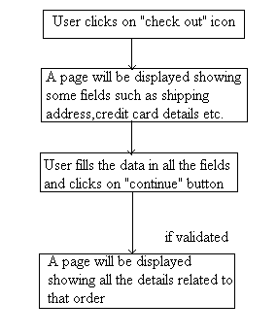

#### 4.5.8.3 Business Rules & Validations

The business rule to be considered while entering this page is the user must click on **Check out** icon.

The business rule to be considered while navigating to next page is the user must provide valid data in all the fields and the user must click on **Continue** button.

### Requirement / Module / Use case for help

#### 4.5.9.1 Description

This use case is used to guide a new user.

REQ-901: If a new user visits the website then he will be guided using this use case. When the user clicks on **Help** link, a page will be displayed guiding the user how to login to and register with **Web store**.

#### 4.5.9.2 Screen Flow / Business Flow & User Actions

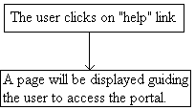

#### 4.5.9.3 Business Rules & Validations

The business rule to be considered while entering this page is, the user must be able to connect to **Web store** and the user must click on **Help** link.

### Requirement / Module / Use case for logout

#### 4.5.10.1 Description

This use case describes the logout action.

REQ-1001: This use case describes about the security reasons so that no other unauthorized user can access the previous user account. After the user clicks on **Sign-Out** link, the user will be directed to **Login** page and the previous user’s session will be set to null.

#### 4.5.10.2 Screen Flow / Business Flow & User Actions

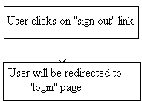

#### 4.5.10.3 Business Rules & Validations

The business rule to be considered while entering this page is the user must be logged in to his account.

## Performance Requirements

* Providing safety for the details which the user enters during registration and during shipping interface-**REQ-1004**
* The system should not crash when multiple users are accessing the portal at a time- **REQ-1105**
* The response time of the system is approximately 1-2 seconds- **REQ-1106**
* Providing the access to the web portal at all times.

## Acceptance Criteria

The above mentioned requirements are the acceptance criteria for the system.

## Logical Database Requirements

### E-R Diagram

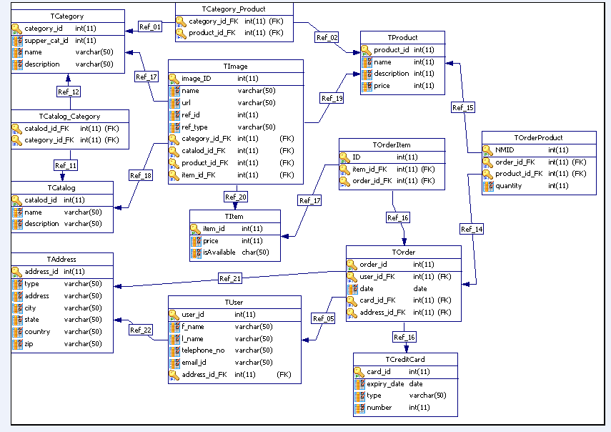

## Design Constraints

It can be run on any server like

* Apache Tomcat,
* Jboss server etc.

## Testing Requirements

Please refer to the attached testing requirements document.

## Compliance to Standards

NA

## Software System Attributes

Functionality

The user can browse through the website for selecting the catalogs categories, subcategories, products; items required for purchasing .he/she can select necessary items in the cart. From the cart he/she can even remove or update the products. These all are the functionalities which are fulfilling the need of the customer.

Suitability

NA

Accuracy

The images, descriptions and prices given in the online portal accurately resemble the original items/products.

Interoperability

NA

Security

The system provides highly secured authentication. The user details which are given during registration, shipping details and credit card information are secured safely.

Reliability

The Web server of the portal is accessible to all kind of customers.

Maturity

NA

Fault tolerance

NA

Recoverability

The details of the products selected into the cart remains in the cart when the user system is abruptly closed, this enhances the recoverability of the system.

Reliability compliance

NA

Usability

* The Home Page is provided with a good overview of all the main key products on sale of the site as well as clearly highlighting information and products to encourage site visitors to review the product ranges and special offers.
* The product categories are also available throughout the site as part of the navigation system to give customers constant access to all the products available and allow the user move easily through the product options.

Understandability

In order to make user Understandable with the operation of the web portal all instructions have been given in the help link which is present on the right corner of the home page.

Learn ability

The Web store portal is designed in such a way that the user can learn about many products without much physical strain.

Operability

There are links provided on the right corner throughout the site as part of the navigation system to give customers constant access to all the web pages available and allow the user move easily through the product options.

Attractiveness

In order to attract the users for accessing the website the home page of the portal comprises of advertisements which provides discounts on purchase of 2 or more products etc.

Usability compliance

NA

Efficiency

Providing the access of the web portal on all times.

It offers 24/7 technical support.

Time Behavior

NA

Resource Utilization

NA

Efficiency Compliance

NA

Maintainability

NA

Analysability

NA

Changeability

NA

Stability

NA

Testability

Each and every field entered by the user is validated to provide secured authentication.

Maintainability Compliance

NA

Portability

It can be accessed on any platform.

Adaptability

NA

Installability

NA

Co-existence

NA

Replaceability

NA

Portability Compliance

NA

Availability

Providing the access of the web portal on all times.

It offers 24/7 technical support.

Safety

The user details which are given during registration, shipping details and credit card information are secured safely.

Environmental

It can run either on Jboss server or ApacheTomcat server environment.

Other Requirements

There are no other requirements apart from the above mentioned requirements

## Statutory and Regulatory Requirements

The system does not have any statutory and regulatory requirements.

## Organizing Specific Requirements

NA

# Derived Requirements

They are no derived requirements for Webstore Application project.

# Validation

## Validation strategy

JUnit testing and GUI testing are used to validate the functionality and requirements of web store.

## Validation criteria

* Accuracy
* Linearity
* Awareness
* Architecture

## Validation Constraints

User can order maximum of 999 items\products of particular type at a time.

Web store runs on intranet only.

More than 100 users cannot access the website at same time.

# References

1. CF_PL_J2EE_WebStoreProject_FunctionalTestCases.xlsx document.

2. Guidance from real-time online shopping Website